**Project Design Phase-II Data Flow**

**Diagram & User Stories**

|  |  |
| --- | --- |
| **Date** | **16 October 2022** |
| **Team ID** | **PNT2022TMID53640** |
| **Project Name** | **Project-Smart Solutions for Railways** |
| **Maximum Marks** | **4 Marks** |

**Data Flow Diagrams:**

A data flow diagram (DFD) is a graphical or visual representation using a standardized set of symbols and notations to describe a business's operations through data movement. They are often elements of a formal methodology such as Structured Systems Analysis and Design Method ([SSADM](https://www.techtarget.com/searchsoftwarequality/definition/SSADM)). Superficially, DFDs can resemble flow charts or Unified Modeling Language ([UML](https://www.techtarget.com/searchsoftwarequality/definition/Unified-Modeling-Language)), but they are not meant to represent details of software logic.

**Example:**

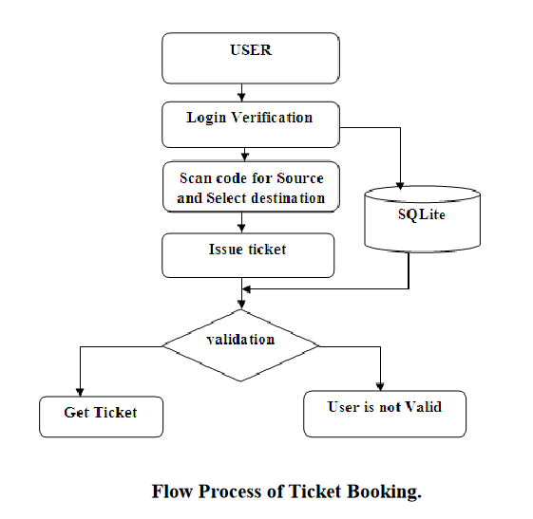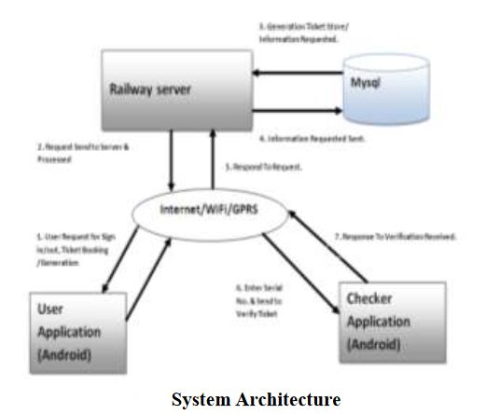

**Architecture:**

**Step 1:** The work here starts during the first time installation of our application where the user has to sign up. During sign up the basic customer information like first name, last name, date of birth, mobile no, city, state etc., will be gathered and it will be stored into MySQL database. So every time when the user buys the ticket this customer information is sent to the database for security purpose and also the tickets generated accordingly. During sign up the username will be set as the user‘s mobile number or Email-id and the password will be as per the choice of the user. On the other hand if the user has an account then he can sign in directly. Thus the user can use different android phones and will not be restricted to only his phone. The above information will be send to server with the help of internet.

**Step 2:** The user scan Qr-code for source and select destination, number of tickets, single or return journey. Then the user is directed to the payment option. Payment can be done through prepaid services, i.e. the balance of the mobile no will be displayed along with the cost of the ticket and if the user agrees to proceed then the equivalent amount of the ticket will be deducted from the balance of the mobile no.

**Step 3:** Once the customer click the buy button a code in the railway server validates the pin number and passwords, if it is successful it saves both the journey details and customer info in the server's MySQL database.

**Step 4:** The code on the server side generates the time of buy and the expiry timing of the ticket; the details are saved in the railway‘s MySQL database. Then Ticket no. is generated on server side, saved in the database and also sent back to the user mobile and saved in the application memory which serves as a ticket for the user.

**Step 5:** In this module the checker will enter the Ticket no. which will validate and verify the journey details from the railway database, especially the time and date of the ticket.

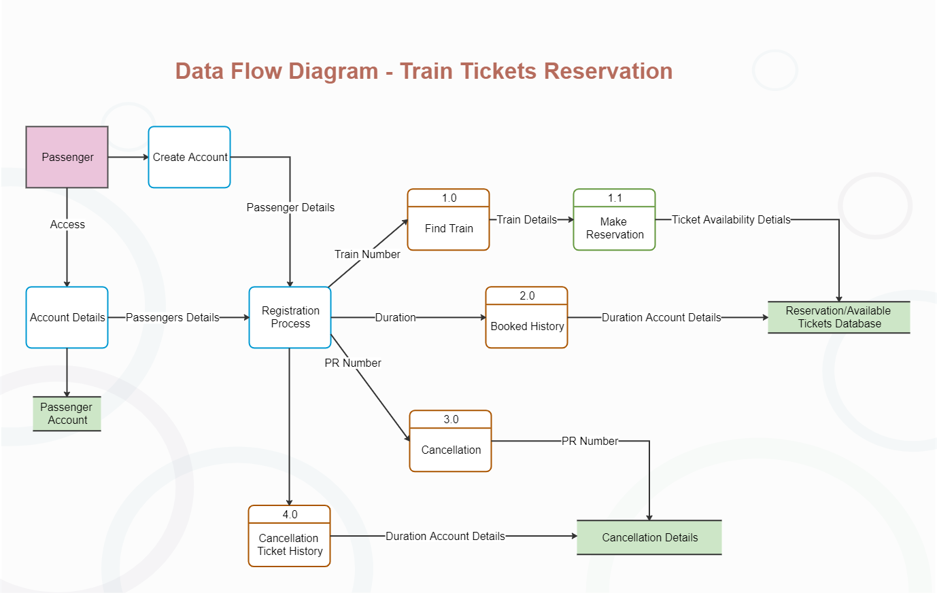

**User Stories**

|  |  |  |  |  |  |  |
| --- | --- | --- | --- | --- | --- | --- |
| **User Type** | **Functional**  **Requirement**  **(Epic)** | **User Story**  **Number** | **User Story / Task** | **Acceptance criteria** | **Priority** | **Release** |
| Customer  (Mobile user) | Reserving ticket | USN-1 | As a user, I can register for the application by entering my email, password, and confirming my password. | I can access my account / dashboard | High | Sprint-1 |
| Customer  (Mobile user) | Reserving ticket | USN-2 | As a user, I will receive confirmation email once I have registered for the application | I can receive confirmation email & click confirm | High | Sprint-1 |

|  |  |  |  |  |  |  |
| --- | --- | --- | --- | --- | --- | --- |
| Customer  (Mobile user) | Reserving ticket | USN-3 | As a user, I can register for the application and enter the details for reserving the ticket. | I can register & access the dashboard with Facebook Login | Low | Sprint-2 |
| Customer  (Mobile user) | Dashboard | Users | The details will be stored safely | I can access it using database | Medium | Sprint-3 |
| Customer (Web user) | Reserving ticket | User | Enter the details and click submit button to book ticket | I can use the QR code which is been generated | High | Sprint-1 |
| Customer Care Executive | Connecting the service provider | Customer | Connects with the service by logging in | Can get connected with the server | Medium | Sprint-3 |
| Administrator | Provides the services | Admin | The data is given by the user | Can add or update the data provided by the user | High | Sprint-1 |